Adding a sine wave and a cosine wave of the same freq produces a sine-wave of the same frequency delayed by **D** seconds (where D is some delay). Call it a **‘sinusoid’.**

A **Periodic wave-form** is any wave-form that repeats itself at time-intervals of **T**, where **T** is the period and **1/T** is the fundamental frequency.

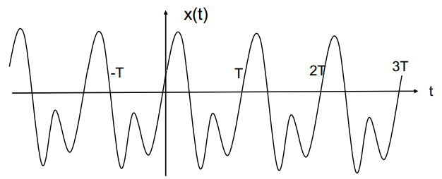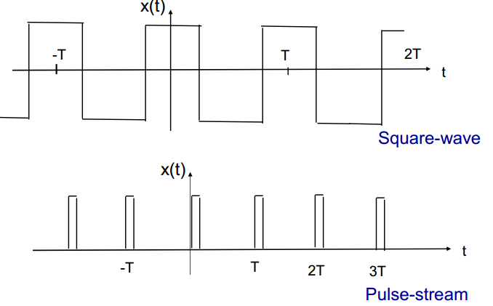

**Non-periodic wave-form** is then what you would expect. E.g. Recording of white noise, the sea, [unvoiced speech](http://iitg.vlab.co.in/?sub=59&brch=164&sim=613&cnt=1). Sound pressure becomes ‘random’.

**Pseudo-Periodic**

Speech and music waveforms are constantly changing. They are not purely periodic (obviously), but if we take a small segment, say 1/20 or 1/50 of a second, (length of a note, say) they can be considered periodic.

They are approximately ‘short-term periodic’, i.e. pseudo-periodic.

**Fourier series**

A periodic segment sample with fundamental frequency **F**, can be represented solely in just sine and cosine waves.

More formally, it decomposes any [periodic function](https://en.wikipedia.org/wiki/Periodic_function) or periodic signal into the sum of a (possibly infinite) set of simple oscillating functions, namely sines and cosines.

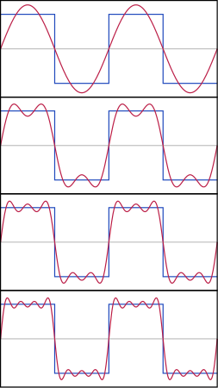(look familiar?)2

Since the series can be possibly infinite, we cannot sample the whole thing. 9e9

We remove all sinusoids of frequency above the sampling freq/2 (Fs/2).

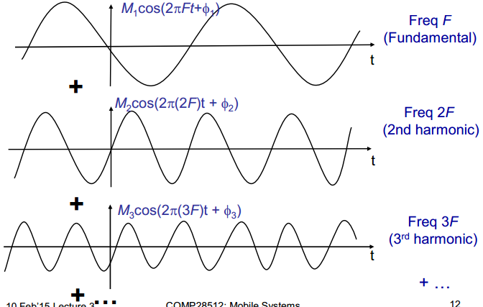

*We combine the waves above and however many more there may be in the fourier series to create the resulting wave we initially perform the transform on.*

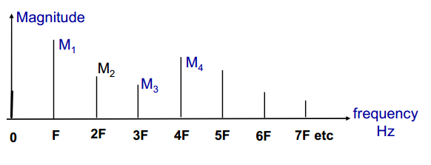

By representing the series in a **line spectrum**(above) we can see what harmonics are present and how strong they are. Represented in the frequency domain.

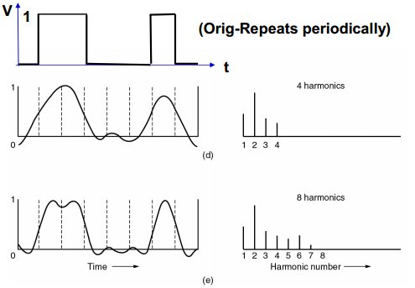

The more harmonics we take, the closer it gets. With 8 harmonics, it starts to resemble the original wave.

**Discrete Fourier Transform**

The DFT converts a sampled waveform segment {x[n]} into a Fourier series representation. Converts from the time-domain to freq-domain.

The **Inverse DFT** converts from freq-domain to time-domain.

**Complex numbers**

In the frequency domain, there are real and imaginary parts, which is difficult to interpret.

We usually convert this to modulus & phase form.

The time-domain signal is usually real, however, strangely, we make it complex and with a zero imaginary part.

Result of DFT is usually complex, even when the signal is real.

**Uses of DFT and its inverse**

1. Spectral analysis
   * finding out what signal components are present
2. Signal processing
   * some processes are best done by converting to the freq-domain first, and then converted back after the processing. Eg filtering out an unwanted sine-wave.

The DFT is much too slow however, therefore we use the Fast Fourier Transform (FFT).

Gives the same result as the DFT only much faster. Also has an inverse function, IFFT.

Some versions of it work best when the number of samples is a power of 2.

Direct DFT programs are really only of academic interest.

**It seems like general consensus that the (scary) maths behind Fourier will not be needed for the exam.**